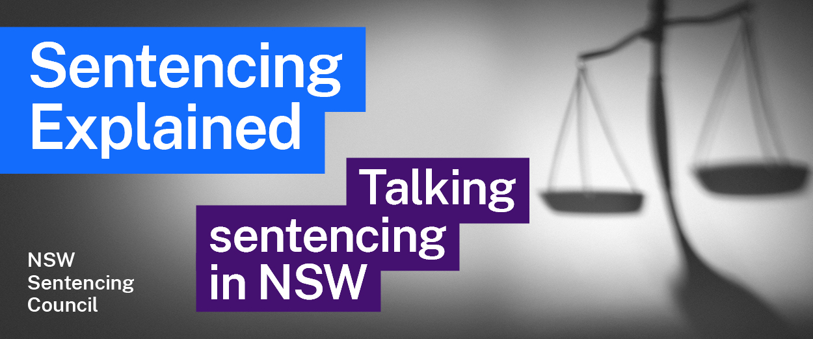Episode 10 Study Guide
Youth justice and sentencing with
President Ellen Skinner, Children’s Court of NSW

Background to the Children’s Court
- Where does the Children’s Court sit? How many specialist children’s magistrates are there in the Children’s Court?
- What is the main Act that outlines how the Children’s Court operates?
- What is the “age of criminal responsibility” in NSW? What does it mean?
- When can a child be charged in the Children’s Court?
- When can the Children’s Court hear cases of young people who are between 18 and 21 years old?
- Which offences does the Children’s Court deal with? When does the Children’s Court transfer matters to the District Court?
- What are “serious children’s indictable offences”? What role does the Children’s Court play when a young person is charged with one of these offences?

Diversionary options
- Which offences can be dealt with under the Young Offenders Act 1997 (NSW)? Which offences cannot be dealt with under this Act?
- The Young Offenders Act 1997 (NSW) outlines a protected admissions scheme. How does this scheme work? Why is it important?
- What options are available to police officers after a young offender has admitted to an offence? See the Young Offenders Act 1997 (NSW).
- What is a youth justice conference? How does it work? In your answer, please explain the role of the victim in these conferences. Find out more on the NSW Government website.

Sentencing in the Children’s Court
- What is the maximum penalty available to the Children’s Court at sentencing?
- When can a criminal conviction be recorded for a young person? If a conviction cannot be recorded, what can the Children’s Court do?
- When a conviction can be recorded, why might a magistrate in the Children’s Court decide not to record one?
- What is a “no conviction bond”? How does this differ from a good behaviour bond?
- What is a juvenile probation order?
- What conditions can be placed on these kinds of orders? What happens if a condition is breached?
- What is a children’s community service order? When is it imposed?
- Explain what a suspended control order is. How does it work? When would it be suspended?

Dealing with young offenders
- What are the guiding principles in the Children (Criminal Proceedings) Act 1987 (NSW) for dealing with young offenders?
- What do you think President Skinner means when she says “many of the offenders in the Children’s Court could also be looked at as victims”? How does President Skinner hope the Children’s Court treats young people who come before it?

Youth Koori Court
- What is the Youth Koori Court? How does it operate?
- Who can access the Youth Koori Court?

Further resources and activities
- Learn more about the Children’s Court and its history on the Children’s Court website.
- Judge Skinner mentions the rate of incarceration of young Aboriginal offenders. Follow the link to access the latest custody statistics for young people from the NSW Bureau of Crime Statistics and Research.

