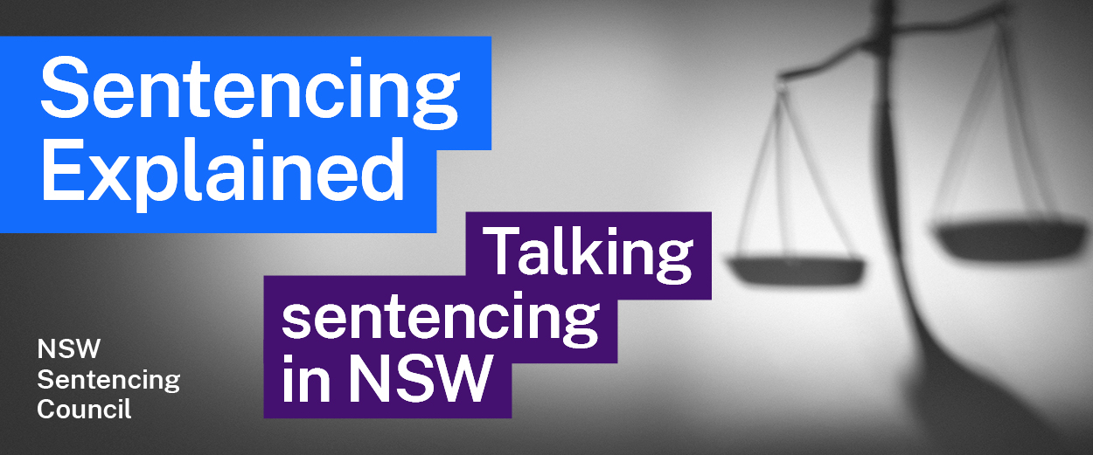Episode 11 Study Guide
Sentencing in the Local Court with Deputy Chief Magistrate Theo Tsavdaridis

Background to the Local Court
- What are the limits for terms of imprisonment in the Local Court?
- Deputy Chief Magistrate (DCM) Tsavdaridis says that the Local Court handles around 360,000 criminal matters in a year, which is approximately 90% of the criminal matters across courts in NSW.
Access this NSW Bureau of Crime Statistics and Research factsheet and look at the statistics on criminal court finalisations by jurisdiction for 2021. How many criminal matters were finalised in the Local Court in 2021? What percentage does this represent of all criminal court finalisations?

Sentencing principles
- Section 3A of the Crimes (Sentencing Procedure) Act 1999 (NSW) lists the purposes of sentencing. Can you think of examples of where the purposes of sentencing might conflict?

Non-custodial sentences
- DCM Tsavdaridis explains that the Local Court can find a person guilty of an offence but make an order dismissing the charge under s 10(1)(a) of the Crimes (Sentencing Procedure) Act. When might a magistrate make this order?
- DCM Tsavdaridis also talks about s 10(1)(b) of the Crimes (Sentencing Procedure) Act, which allows the court to make a conditional release order under s 9 of the Act. Summarise the example used by DCM Tsavdaridis that shows how this order works.
- What is a community correction order? How is this different to a conditional release order?

Custodial sentences
- Section 5 of the Crimes (Sentencing Procedure) Act says the Court must not sentence an offender to imprisonment unless no other penalty is appropriate. What does DCM Tsavdaridis consider before sentencing an offender to imprisonment?
- What is an intensive correction order (ICO)? See the websites of Corrective Services NSW and the Sentencing Bench Book.
- When can a court impose an ICO? See ss 66 to 68 of the Crimes (Sentencing Procedure) Act.
- Describe the three-step process that DCM Tsavdaridis follows when determining if an ICO is appropriate for an offender.
- Section 44 of the Crimes (Sentencing Procedure) Act sets out how a court will determine the non-parole period for a prison sentence. If a judge imposes a prison sentence of 4 years, what will the non-parole period be (if there are no “special circumstances”)?

Breach of sentencing orders
- If an offender breaches a community correction order by not engaging with community corrections, what is the process for dealing with the breach?
- What happens if the offender breaches a community corrections order by committing another crime?
- Breaches of an ICO are dealt with based on the severity of the breach. Follow the link to the NSW State Parole Authority website and describe how it deals with:
- less serious breaches, or
- more serious breaches.

Further resources and activities
- Crimes (Sentencing Procedure) Act 1999 (NSW)
- NSW State Parole Authority Home Page

