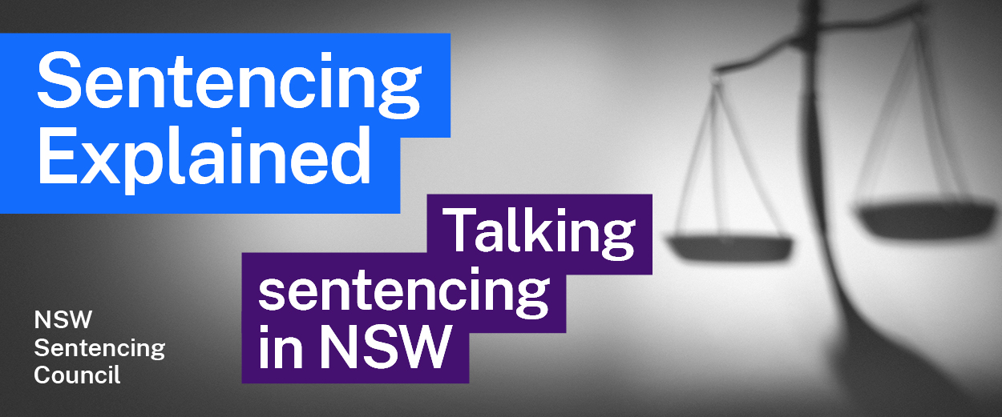Episode 16 Study Guide
Sentencing Aboriginal offenders on the Walama List with Justice Dina Yehia

Background
- Justice Yehia has had an extensive career. Which roles has she held?
- Justice Yehia mentions Bugmy v The Queen [2013] HCA 27. What was the decision in this case? This summary by the Human Rights Law Centre may help you.

Background to the Walama List
- What is the Walama List?
- Using the Walama List Fact Sheet and District Court Criminal Practice Note 26, explain each of the following:
  - What does the word Walama mean?
  - What are the objectives of the Walama List?
  - Who is eligible for referral to the Walama List?
- Are there any limitations to who is eligible for referral to the Walama List?

Operation of the Walama List
- How does the Walama List operate?
- What is the role of the Aboriginal Service Unit in supporting the Walama List? Outline their role in preparing the intake form in your answer.
- What is the role of the prosecutor in the Walama List procedure?
- How can victims participate in the Walama List procedure?
- What is the role of caseworkers?
- What is a “sentencing conversation”?

Case plans
- What is a case plan? How is it prepared? Describe the roles of the people who contribute to preparing the case plan.
- Why is the development of a case plan more difficult for offenders who remain in custody?
- How will the case plan differ to those offenders who are on bail?
- Why may an offender not be sentenced for up to 12 months? What happens during this time? Why is this important to the final sentence that is imposed?

Reflections about the Walama List
- What is the offender told from the outset about their participation and progress in the Walama List? Why is this important?
- What happens to offenders if they have been on the program for 12 months but “haven’t been doing very well”?
- Once an offender has been sentenced, they have no further involvement with the Walama List. Why does Justice Yehia think this should change?

Further resources and activities
- Justice Yehia was previously a Deputy Senior Public Defender. Listen to Episode 4: The Role and Duty of Defence Counsel to hear the Senior Public Defender, Belinda Rigg SC, describe the work of the Public Defenders.

