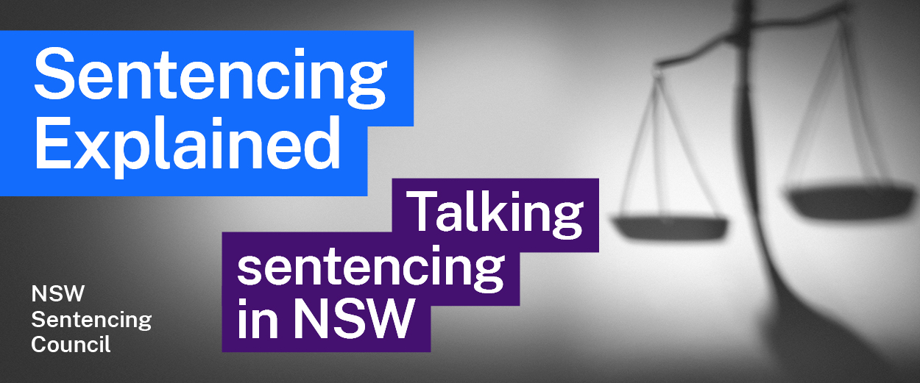Episode 4 Study Guide
The role of a criminal defence barrister with
Senior Public Defender Belinda Rigg SC

Background
- Describe Belinda’s career path to become Senior Public Defender. What was unusual about it?
- Why does Belinda consider working in the criminal law so important?

Key concepts
- Belinda mentions many legal concepts, which are discussed in the crime topic in the HSC syllabus. Explain what is meant by each of these terms:

- subjective matters
- objective matters
- motivation
- provocation
- duress
- mental illness
- cognitive impairment
- social deprivation
- remorse
- criminal history

Role of Public Defenders
- What is the role of the Public Defenders? Who do they represent?
- Which courts are Public Defenders mostly engaged in?
- What steps does a Public Defender take to prepare for a sentencing hearing for an offender who has been found guilty or has pleaded guilty?
- What factors might Public Defenders consider when deciding whether to call an offender to give evidence at a sentencing hearing?
- Take a look at The Public Defenders: Annual Review 2020-21. What does the table on page 5 tell you about the work of the Public Defenders?

Bugmy Principles
- The High Court case of Bugmy v R [2013] HCA 37, 249 CLR 571 transformed how judges look at an offender’s background of deprivation that could have contributed to their offending. How does Belinda describe the principles from this case?
- What is the Bugmy Bar Book? Who helped establish it?

Submissions on sentences of imprisonment
- Consider section 5(1) of the Crimes (Sentencing Procedure) Act 1999 (NSW). What does a court have to consider before it can sentence an offender to imprisonment? What does Belinda say happens after this threshold has been crossed?
- When may a Public Defender argue for a certain term of imprisonment?
- How does a Guideline Judgement affect the way a Public Defender may make submissions on the length of a sentence of imprisonment? What is the effect where there are co-offenders?

Sentence appeals from offenders
- In appeal cases, what is the role of the Legal Aid Indictable Appeals Unit?
- Belinda mentions that clients must pass the means and merit tests before being granted legal aid for an appeal of a criminal case. What are these tests?
- What is the difference between a conviction appeal and a sentence appeal?
- Belinda mentions “an application for leave to appeal”. What does this mean?
- Explain the process for the Public Defenders to appeal from a decision of the Court of Criminal Appeal to the High Court.

Further resources
- Websites of the Public Defenders and Legal Aid NSW

