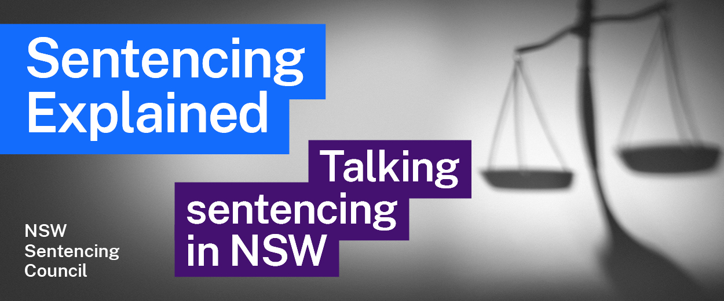Episode 1 Study Guide
Insights into sentencing reform with
the Hon Bob Debus AM

Former Attorney General of NSW

Historical context
- Mr Debus had various roles in government. What were these roles and what did they involve?
- What social, criminal and political factors led Mr Debus to realise there was a need “to return confidence in the judiciary and the sentencing process”?
- Why was Mr Debus concerned about the role of the media at that time?
- What is the “Devil’s Triangle” that Mr Debus refers to and why was it challenging?
- What actions did Mr Debus take to address these concerns?

Laws and law reform in NSW
- What is mandatory sentencing? Why was Mr Debus concerned about the possible introduction of mandatory sentencing?
- What are standard non-parole periods? What led Mr Debus to conclude they are a more realistic approach than mandatory sentencing?
- Explain the concept of judicial discretion. Why is it an important cornerstone of the criminal justice system?
- Why does Mr Debus think “law and order politics is the enemy of judicial discretion”?
- The maximum sentences and standard non-parole periods are “guideposts” for judges. What does this mean?
- What are Guideline Judgements and why were they introduced?
- What aggravating and mitigating factors can a judge consider at sentencing? (Hint: see Crimes (Sentencing Procedure) Act 1999 (NSW) s 21A).

The role of the Sentencing Council
- What did Mr Debus see as the role of the Sentencing Council?
- Visit the Sentencing Council website. Who is on the Sentencing Council? Why do you think this diverse membership is important to achieving the purpose of the Council?
- The Sentencing Council often considers sentencing practices in other countries, as well as other states and territories across Australia. Why is this useful when looking at law reform?

Further resources and activities
- The Sentencing Council reports annually on sentencing trends in NSW. Visit the Council’s website and explore the most recent annual report. Identify the most common penalties and explain the true situation of sentencing today.
- The Bureau of Crime Statistics and Research (BOCSAR) publishes quarterly reports on crime trends in NSW. Visit BOCSAR’s latest report. Choose three offence categories and explain the current situation and trends for those offences.
- To explore the functions and constitution of the Council see Crimes (Sentencing Procedure) Act 1999 (NSW) part 8B.
- Learn more about the Devil’s Triangle in Bob Debus’ lecture titled “The Devil’s Triangle: civil liberties, the media and parliament”.

