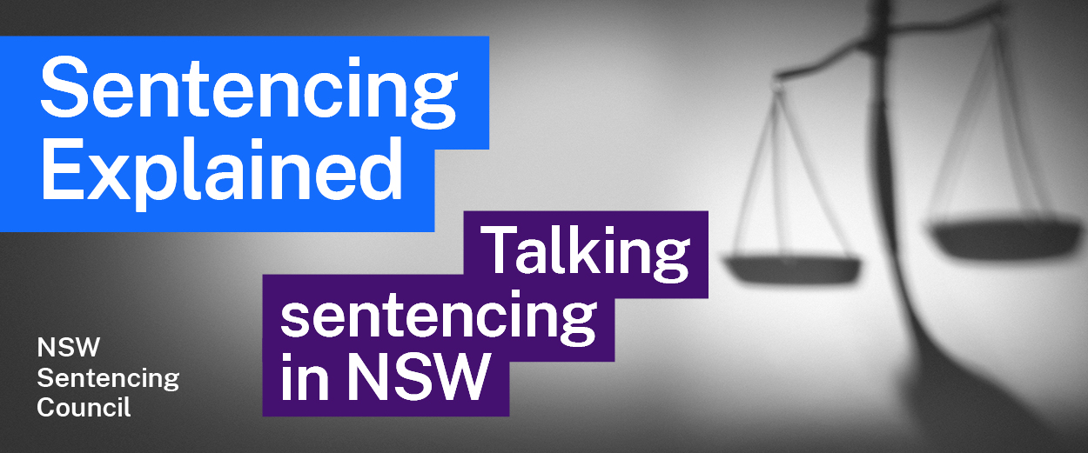Episode 9 Study Guide
Talking sentencing law, education and society with Wayne Gleeson

Legal Studies in NSW
- When was Legal Studies first assessed for the Higher School Certificate?
- Peter believes it is important for members of the public to understand how the legal system works. Discuss this idea in pairs, focusing on why it is particularly important to understand sentencing law.
- According to Wayne, what two things are students surprised to learn when they study sentencing? As a class, discuss what these mean for the legal system and for our society.

Sentencing reform
- According to Wayne, what are some examples of factors that drive law reform?
- What role does the Sentencing Council play in law reform? You can visit the Sentencing Council's website for assistance.
- Who has the ‘final say’ when it comes to changing the law?

The NSW Sentencing Council
- The members of the NSW Sentencing Council bring different perspectives and experiences to the Council. Look at the list of current Council members. Who is currently on the Council? Why is it important to have a diverse range of Council members?
- Wayne mentions two recent reviews completed by the Council, which considered:
- fire offences (2019), and
- assaults on emergency services workers (2021).
- What did the Attorney General ask the Council to consider in these reviews (hint: look for the “terms of reference”)?
- What were some of the Council’s recommendations in these reviews?
- How did the Government respond to the Council’s recommendations in its Assaults on Emergency Services Workers report?

Further resources and activities
- The NSW Bureau of Crime Statistics and Research (BOCSAR) provides statistics about the criminal justice system in NSW. Visit the BOCSAR website to see the latest crime statistics, custody statistics and reports on topics that are relevant to the Legal Studies syllabus.
- Visit the Sentencing Council's website to learn more about the Council’s work and read its past reports.
- Visit the Law Reform Commission's website to learn more about the Commission’s work and access its past reports.
- Visit the NESA website to access the Legal Studies Syllabus and support materials as well as the Legal Studies examination packages.

