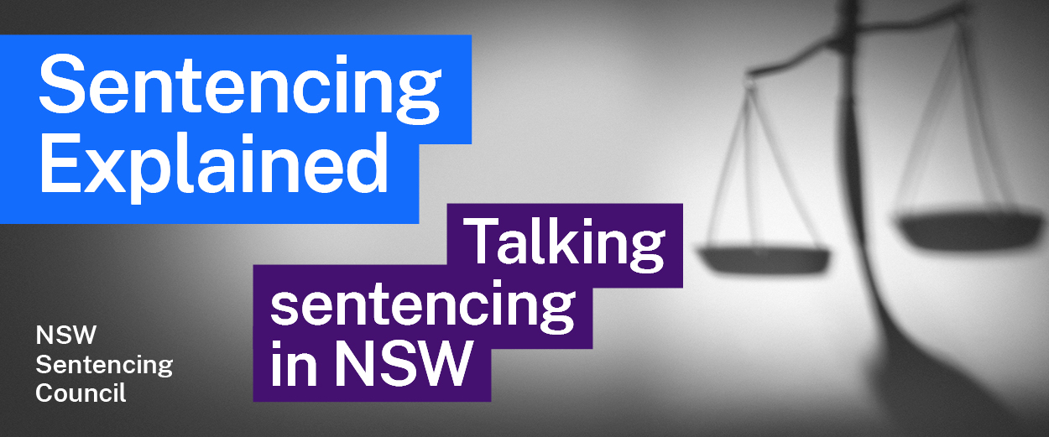Episode 9 Study Guide
Police, sentencing and alternative pathways with Assistant Commissioner Scott Cook, NSW Police Force

Background to Assistant Commissioner Cook and the NSW Police Force
- Scott Cook is an Assistant Commissioner in the NSW Police Force. Describe his career path to his current position.
- How did the NSW Police Force come into existence?
- Which police officers can lay charges before the courts?

Police powers and discretion
- What are the police powers in relation to young people who may have committed a crime? In answering this question, look at the Young Offenders Act 1997 (NSW).
- What is police discretion? Why is it important when dealing with young people, in Assistant Commissioner Cook’s view?
- What is the RISEUP program, which is mentioned by Assistant Commissioner Cook? To find out more, visit the PCYC website.
- What discretion do police have with adults?

Warnings and cautions
- What is involved in a police warning under the Young Offenders Act 1997 (NSW)?
- What can be the future consequences of these warnings for young people?
- Explain how a formal caution works, including the role of the Youth Officer.
- What offences can be dealt with by a formal caution?
- Explain how a Youth Justice Conference works.

EAGP process
- What is the Early Appropriate Guilty Plea (EAGP) process? Further information on the EAGP process can be found on the Legal Aid website.

Role of police prosecutors
- How many police prosecutors are there? Explain how the training program for police prosecutors works.
- In which courts do police prosecutors appear?
- What role does the police prosecutor play in the sentencing process of the Local Court?
- What criminal history of the offender would a police prosecutor present in a sentencing hearing at the Local Court?
- What role do police prosecutors play in providing victim impact statements to the court? What obligations do police prosecutors have to victims?
- Explain the role of the police prosecutor in Circle Sentencing.

Further resources and activities
To find out more about the role of police prosecutors, visit the Police Prosecutions Command webpage.
Relevant legislation:
- Police Act 1990 (NSW)
- Young Offenders Act 1997 (NSW)
- Crimes (Sentencing Procedure) Act 1999 (NSW)

